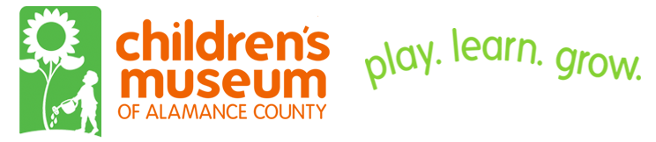
The Children’s Museum of Alamance County wants you to become a “Friend of CMAC” with an annual pledge of $25.00. CMAC “Friends” provide the financial means to maintain activities and operations at the Children’s Museum of Alamance County from year to year.
“Friends” donate a minimum of $25 a year. In return, they receive a decal sticker appropriate for vehicles, a visible acknowledgement of their support wherever they go.
For additional opportunities – sponsorships, memberships, and endowments – please contact CMAC at 336-228-7997 or manager@childrensmuseumofalamance.org.

Your Name _________________________________________ Today’s Date ____________

Address ___________________________________________________________________

City ______________________________________________ State ____ Zip ________

Telephone (day) _______________________________ (other) _______________________

Email _______________________________________ (other) ______________________

I want to be a “Friend of CMAC” at the $25 level of support every year.
I want to be a “Friend of CMAC” at a higher level of support every year.

$ _____ Total Contribution

Method of Payment: Cash Check #______ Send me an invoice
Credit Card (optional) # _______________________
Expiration Date ________ Zip Code ________

*No goods or services were provided to you in consideration of this gift. This is not a membership to the museum and does not come with any privileges except a listing on the website. Our federal tax identification number is
42-1740709. The Children’s Museum of Alamance County is a 501(c)(3) tax exempt organization, IRS Section 170(b)(2)(iii) for both federal and state tax purposes.
P.O. Box 1178
Graham, NC 27253
336-228-7997
www.childrensmuseumofalamance.org

